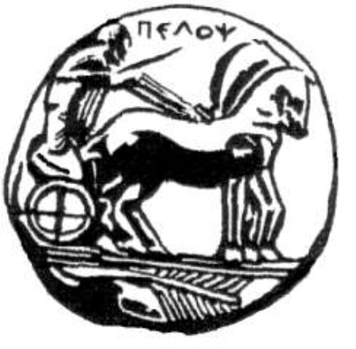
[Sparta 2018]
POSTGRADUATE STUDIES PROGRAMME
“Organization and Management of Sports Activities for Persons with Disabilities (A.me.A.)”
Address: Ave. Efstathiou & Stamatikis Valioti & Plataion,
Sparta, P.C. 23100, Tel.: 27310-89661, Fax: 89657, email: chios@uop.gr
GUIDE TO WRITING
THE MASTER’S THESIS


[Department of Sports Organization & Management, University of the Peloponnese] | ©

Contents
Contents | Page
1. PART A: Structure and formatting of the Master’s Thesis | 2
2. Part B: Notes on the bibliography | 15
3. Part C: Academic ethics and research integrity issues | 17

About this guide
This guide provides instructions on:
- Structure and formatting, to ensure that all copies of your Master’s Thesis (MT) are presented in the correct form (Part A).
- Writing bibliographic citations in the text and in the bibliography according to the style recommended by the American Psychological Association (APA, 6th Ed.) (Part B).
- Raising awareness of, and recognizing, the importance of academic ethics when writing scientific papers, together with appropriate compliance practices and examples for avoiding plagiarism (Part C).

Part A: Structure and formatting of the Master’s Thesis
Instructions on structure and formatting to ensure that all copies of the Master’s Thesis are presented in the correct form. Where a choice of language is possible, samples are provided in both Greek and English. Before the thesis is submitted to the PSP, make sure that the pages are arranged in the following order:

A.1 Order of the pages
- Title page (see the sample page)
- Copyright page (see the sample page)
- Abstract in Greek (see the sample page)
- Abstract in English (see the sample page)
- Preface, with acknowledgements, dedications, etc. (optional)
- Contents, listing the corresponding page numbers
- List of Tables, with the relevant titles and the corresponding page numbers
- List of Figures, with titles and page references
- List of Images, with titles and page references
- List of Abbreviations & List of Symbols
- Main text of the MT (which includes the Introduction, the Literature Review, the Methodology, the Results and the Discussion – Conclusions)
- Bibliography
- Appendices (if any, e.g. the questionnaire that was used)

A.2 Page numbering
From number 1 to 11 (from the title page up to and including the list of symbols) the pages are numbered with Roman numerals, starting from the copyright page and not from the title page. The pages are numbered at the bottom right.

A.3 Text format
Throughout the MT the following must be observed:
- Font: Times New Roman 14 for chapter titles (bold), 12 for subchapter titles (bold) and 12 for the main text.
- Paragraph: Line spacing (Format, Paragraph, Spacing): 1.5 lines.
- Alignment: Justified text.
- Title and headings: The title of the MT is written in capital letters (Times New Roman 16, bold) and is centered on the page. It should be as short and comprehensive as possible.
- Paragraphs: the first line of each paragraph starts with an indent of 1.27 cm.
More specifically, the following apply to each individual part of the MT:

A.4 Title page
The title page of the Master’s Thesis of the PSP “Organization and Management of Sports Activities for Persons with Disabilities (A.me.A.)” must provide the following:
- The title of the MT, centered, five (5) centimetres below the top of the page (Times New Roman 16, bold).
- The name of the student, centered, 2.5 centimetres below the title (Times New Roman 12).
- The following statement, within the full margins, 2.5 centimetres below the student’s name:
Master’s Thesis submitted to the Three-Member Examination Committee in partial fulfilment of the requirements for the postgraduate degree of the Postgraduate Programme “Organization and Management of Sports Activities for Persons with Disabilities (A.me.A.)” of the Department of Sports Organization and Management of the School of Human Movement and Quality of Life Sciences of the University of the Peloponnese.
- In the lower half of the page, centered, the following words: Sparta: 201___ (year of submission of the MT).
- On the right side, the following words: Approved by: (the names of the Three-Member Examination Committee, i.e. of the supervising professor and the other two members, together with their rank, are given, numbered i), ii), iii)).
Sample: Title page of the MT (in Greek)
TITLE OF THE MASTER’S THESIS
(centered, 5 cm below the top of the page)
by (full name of the student)
Master’s Thesis submitted to the Three-Member Examination Committee in partial fulfilment of the requirements for the postgraduate degree of the Postgraduate Programme “Organization and Management of Sports Activities for Persons with Disabilities (A.me.A.)” of the Department of Sports Organization and Management of the School of Human Movement and Quality of Life Sciences of the University of the Peloponnese
Sparta (year of submission)
Approved by the Three-Member Examination Committee:
1. Supervisor: rank (full name)
2. Member: rank (full name)
3. Member: rank (full name)

A.5 Copyright page
The copyright page is placed after the title page and carries the copyright notice, the reservation of rights and the terms of use of the thesis, as shown in the sample below (bottom of the page).
Sample: Copyright page (bottom of the page)
Copyright © Full name of the author, year of submission
All rights reserved.
Copying, storing and distributing this work, in whole or in part, for commercial purposes is prohibited. Reprinting, storing and distributing for non-profit, educational or research purposes is permitted, provided that the source is cited and this notice is retained. Enquiries concerning the use of this work for profit-making purposes should be addressed to the author. The views and conclusions contained in this document express the author and should not be interpreted as representing the official positions of the Department of Sports Organization and Management of the School of Human Movement and Quality of Life Sciences of the University of the Peloponnese.

A.6 Abstract page
Every copy of the Master’s Thesis must contain one abstract in Greek and one in English (regardless of the language in which the thesis is written). The abstract must not exceed 300 words. The abstract must be written entirely in a single paragraph. Finally, the keywords (at most 5 words) must be given at the bottom.
- The word “ABSTRACT” (in the Greek abstract: “ΠΕΡΙΛΗΨΗ”) is placed centrally, five (5) centimetres below the top of the page.
- Below it follows the name of the student and the title of the Master’s Thesis.
- In parentheses, centered below the title, the phrase (Under the supervision of __________________________) is written, including the name of the supervising professor together with his/her rank.
Sample: Abstract page in Greek (English translation of the Greek sample)
ABSTRACT (Greek: ΠΕΡΙΛΗΨΗ)
Zacharias D. Agraniotis: State and trait anxiety of police officers and strategies for coping with stressful situations.
(Supervised by Mr Antonios Travlos, Professor, T.O.D.A.).
The purpose of this study was to evaluate state (transient) anxiety and trait (temperamental) anxiety, as well as the Ways of Coping with Stressful Situations (WCSS) of police officers according to gender, marital status (unmarried, married), rank (constable, non-commissioned officer, officer), type of service performed (indoor, outdoor, indoor and outdoor), the service they serve in (Security Department, Police Station & Mixed, Traffic Department, Headquarters), education (high school graduate, technological institute graduate, university graduate), and the seat of the Police Department (province, Athens). Two hundred and two police officers from selected police services of the Prefectures of Laconia, Arcadia and Attica took part in the study. The sample completed a questionnaire of socio-demographic characteristics, Spielberger’s anxiety inventory (STAI), and the WCSS questionnaire of Lazarus and Folkman. For the data analysis, Pearson correlations, simple multivariate analyses of variance (MANOVA), t-tests and simple analyses of variance (ANOVA) were carried out. The results of the study showed that, as a whole, police officers have “normal” levels of anxiety. The correlation between trait and state anxiety ranged at levels suggesting that police officers with high levels of trait anxiety also exhibit high levels of state anxiety. The findings indicate that (a) female police officers experience higher levels of state and trait anxiety than male police officers, (b) trait anxiety varies according to the rank of the officers and (c) the WCSS vary according to the gender, rank, service and marital status of the police officer.
Keywords: anxiety of police officers, work stress, coping strategies.

Sample: Abstract page in English
ABSTRACT
Zacharias Agraniotis: State–trait anxiety of police officers and stress coping strategies
(With the supervision of Dr. Travlos Antonios, Professor).
The purpose of this study was to evaluate state and trait anxiety, as well as stress coping strategies of police officers according to gender (male, female), marital status (unmarried, married), grade (police officer, police second sergeant to police warrant officer, police second lieutenant to police lieutenant general), by type of service performed (indoor, outdoor, indoor and outdoor), police department they serve (security police department, police station and mixed police station, traffic police department, headquarters), education (high school graduate, technological educational institution graduate, university graduate) and headquarters of police departments (province, Athens). Two-hundred-two police officers participated in the study from selected police departments of Laconia, Arcadia, and Attica. The participants completed a socio-demographic profile questionnaire, Spielberger’s State-Trait Anxiety Inventory (STAI) and the Lazarus and Folkman’s Ways of Coping questionnaire. Pearson product moment correlations, simple multivariate analyses of variance (MANOVA), t-test and one-way analyses of variance (ANOVA) for independent samples were used to analyze the data. The results of the research showed that, as a whole, police officers have “normal” levels of state and trait anxiety. The correlation between trait and state anxiety has ranged to levels suggesting that police officers with high levels of trait anxiety, also exhibit high levels of state anxiety. From research findings, it appears that (a) female police officers experience higher levels of state-trait anxiety than male police officers, (b) trait anxiety varies according to the grade of the officers and (c) the Ways of Coping (strategies) vary according to gender, grade, police department they serve, and marital status of the police officer.
Keywords: Anxiety of police officers, work stress, coping strategies.

A.7 Contents page
- The heading should simply read CONTENTS, in capital and bold letters (Times New Roman 14, bold), and be placed centered 2.5 centimetres below the top of the page.
- The structure of the contents must follow the form of the sample.
- It must include all parts of the MT, with the exception of the preliminary pages [title page, dedication (if any), acknowledgements page].
- It is preferable to use a table insertion for better alignment, where the chapter titles are left-aligned, while the page references are in a second column at the right margin (alignment). Alternatively, the proposed form can be created with a Word command, after appropriate formatting.
- The same applies to the lists (list of tables, figures, abbreviations, etc.). All titles of the lists are written in capital letters, Times New Roman 14, bold.
See the sample of the Contents and of the lists below.
Sample: Contents page
CONTENTS
ABSTRACT (Greek) 9
ABSTRACT (English) 10
CONTENTS 12
LIST OF TABLES 13
LIST OF FIGURES 14
LIST OF ABBREVIATIONS 15
CHAPTER I 17
INTRODUCTION 17
1.1 Theoretical basis of the topic under investigation 17
1.2 Identification and delimitation of the problem 17
1.3 Purpose of the study 18
1.4 Research hypotheses 18
1.5 Delimitations – Limitations 19
1.6 Definitions of terms 19
CHAPTER II 20
LITERATURE REVIEW 20
2.1 Theoretical approaches (of the topic under investigation – e.g., anxiety) 21
CHAPTER III 22
METHOD 22
3.1 Sample 22
3.2 Data collection instruments 22
3.3 Data collection procedure 22
3.4 Statistical analysis 22
CHAPTER IV 23
RESULTS 23
CHAPTER V 26
DISCUSSION 26
BIBLIOGRAPHY 27
APPENDICES 28

List of Tables
Sample: List of Tables
LIST OF TABLES
Table | Title | Page
1 | Mean values and standard deviations, etc… | 25
2 | Summary table, etc. | 27
3 | etc.
4

Note: Pay attention to the formatting of the table: the table lines must not be visible after the numbering of the Tables.

List of Figures
Sample: List of Figures
LIST OF FIGURES
Figure | Title | Page
1 | Mean values and standard deviations, etc… | 26
2 | ……. | 28
3 | etc.
4

Note: Pay attention to the formatting of the table: the table lines must not be visible after the numbering of the Figures.

List of Abbreviations
Sample: List of Abbreviations
LIST OF ABBREVIATIONS
ANS: Autonomic Nervous System
PwD: Persons with Disabilities (Greek: ΑμεΑ)
TRS: Teaching and Research Staff

Note: Pay attention to the formatting of the table: the table lines must not be visible. The abbreviations are listed alphabetically.
The main text of the MT follows (which includes the Introduction, the Literature Review, the Methodology, the Results and the Discussion/Conclusions).

A.8 Main text of the MT
General remarks for CHAPTER I
- The problem and the research approach are presented.
- A preliminary and brief review of the literature related to the problem is made.
- The theoretical background of the research is presented, which contributes to the formulation of appropriate research hypotheses and justifies the possible findings of the research (predictions of the theory or theories).
- The significance of the research, as well as its originality, is stated.
- It concludes with the purpose, where in 4-5 lines the aims of the specific research are stated precisely.
- The research hypotheses and the statistical hypotheses of the research are written.
- At the end of this chapter the limitations and delimitations of the research are stated.
- The theoretical and operational definitions of the most important terminology are also stated.
CHAPTER I
INTRODUCTION
The purpose of the introduction is to help the reader understand the scientific background of the paper. The introduction defines the research problem and the research approach (even if the research is a review). It presents scientific literature with research findings related to the problem and ends with the studies most relevant to the topic of the MT. It should focus only on those earlier studies that are directly related to the current study, and no attempt should be made to cite all the research in a broad area.
In the case of a review study, the researcher uses all the studies that are relevant to the research questions. Note: in review studies the term research hypotheses is not used; research questions are used instead.
1.1 Theoretical basis of the topic under investigation
This subchapter describes the theories that are relevant to the concepts the paper deals with. The theories are developed with particular care. The correct presentation of the theory or theories will help in creating the appropriate research hypotheses and in justifying the findings of the research.
1.2 Identification and delimitation of the problem
The main aim, after identifying a series of studies, is to decide which studies are related to the topic. This can be done by carefully studying recent articles, and especially review articles or meta-analyses. Once some key studies have been identified, a careful reading of them will usually generate various ideas and open questions (formulation of research questions or, in the case of a review, delimitation of the development of the review approaches).
In this subchapter the researcher-author states how the results of his/her research will contribute to reducing the existing scientific gap. He/she will achieve this with appropriate argumentation and by using the conflicting results of previous studies that are relevant to the topic of the study conducted and to the limitations noted in them. It is obvious that if the researcher-author manages to convince the reader that no satisfactory answers have been given for the topic under investigation, this would strengthen its importance.
NOTE: The scientific gap of the paper must be shown here in detail, and the necessity as well as the originality of the research must follow from it.
1.3 Purpose of the study
As mentioned, when the researcher-author writes the introduction with corresponding skill and defines the problem precisely, the reader arrives on his/her own at the purpose of the paper, and its formulation presents no difficulty. Both the independent and the dependent variables must be defined.
1.4 Research hypotheses
In this subchapter the hypotheses are recorded (first the research hypotheses and then the statistical – null – hypotheses), depending on what the type and design of the research require. It is good for the hypotheses to appear to follow naturally from everything that precedes.
NOTE: If a reader considers some or all of the hypotheses to be a surprise, given what the researcher-author has stated previously, the introduction has not been structured correctly and the researcher-author has failed to define the rationale for the current study.
The research hypotheses are presented in the following form:
Ha1: The first research hypothesis
Ha2: The second research hypothesis
Ha3: etc.
The statistical hypotheses (null hypotheses) are presented in the following form:
Ho1: The first statistical hypothesis
Ho2: The second statistical hypothesis
Ho3: etc.
1.5 Delimitations – Limitations
Every study has limitations, which are the possible inadequacies or influences that either cannot be controlled or are the results of the delimitations imposed by the researcher. Some limitations refer to the purpose of the study, which is usually imposed by the researcher.
1.6 Definitions of terms
The theoretical and operational definitions of the most important terminology used in the research are written. The definitions must also refer to the scientific literature (where required).
CHAPTER II
LITERATURE REVIEW
In this chapter the researcher-author summarizes what is known about the scientific area that his/her research will cover. In order to substantiate his/her research proposal, he/she has already acquired the basic theoretical background required, having found many works relevant to the topic being handled, read them carefully and recorded the researchers’ proposals. In general, this chapter includes an extensive discussion of the relevant literature, as recent as possible. More specifically:
- This chapter includes an extensive discussion of the relevant literature, as recent as possible.
- The researcher-author should remain focused on the specific topic and limit the description of studies with more general conclusions.
- When describing older studies, unimportant details should be avoided.
- Emphasis should be given to the relevant findings, the relevant methodological issues and the most important conclusions.
- The research findings should be developed so that they can be understood by the broad scientific community and not only by very specialized readers.
- The researcher-author must keep a critical stance towards the studies and deal in a fair and scientific manner with controversial conclusions.
- The researcher-author may divide the literature review into subchapters, giving the appropriate numbering and title to each subchapter.
Note: If the theoretical basis of the research was not developed clearly in the introduction of the paper, it is recommended to create a separate subchapter in which the theory or theories relevant to the research are developed. This subchapter is presented before the development of the literature review. The title of the subchapter will be:
2.1 Theoretical approaches (of the topic under investigation – e.g., anxiety)
CHAPTER III
METHOD
Before presenting the sample, the researcher may make general remarks on the methodology followed for conducting the research. If all of this is presented in the sections below, the researcher starts with the subchapter on the sample.
3.1 Sample
The characteristics of the participants (gender, age, demographic data, etc.), the selection procedure, the methodology used for determining the sample size, etc. are described.
3.2 Data collection instruments
The data collection instruments (means) that will be used are described, together with their reliability and validity, accompanied by the appropriate bibliographic references. Also, when original or complex instruments (tests, questionnaires, experiments) are included, they must be described in detail.
3.3 Data collection procedure
Information is given on how the sample was selected, how the participants were approached, the instructions given for completing the questionnaires or interviews or the experiment, the time needed to carry out the research, as well as the place where it was conducted. The writing must be detailed and must allow the reader to understand fully the course of the procedure (step-by-step approach). The author describes the procedure in such a way that any researcher, by reading it, can repeat the research in exactly the same way.
3.4 Statistical analysis
The independent variables (e.g. groups), the dependent variables (e.g. performances) and the type of statistical procedure (type of statistical analysis used for each variable or for each research hypothesis/statistical hypothesis) are described.
CHAPTER IV
RESULTS
The presentation of the results is the most important part of the research.
- The results are written in a separate chapter in an order related to their statistical analysis (method section) and to the research hypotheses of the study.
- For a better presentation of the results, the researcher may create separate subchapters with a numbering and a subchapter title.
- At the beginning, the author writes the descriptive statistics, reporting means and standard deviations for all dependent variables and for all experimental conditions. Within one properly structured paragraph, the researcher is expected to present the descriptive statistics of the study, referring the reader to the relevant Table(s). If these data are too many, only the important tables are included in the results section and the rest are placed in the appendix.
- Next, the differences between the variables, the level of significance and the possible correlations among them are reported.
- To make the statistical indices easier to understand, they are written in italics, and for each index (r, t, F, χ²) the degrees of freedom (df), the significance (p) and the effect size (as appropriate: effect size, η², partial η²) are reported.
- If the researcher-author uses post hoc analysis, this must be reported (Bonferroni, Tukey, Scheffé, etc.).
- To make the results more understandable, their description is combined with tables, figures and images.
NOTE: In this chapter the statistical findings are presented and the results are NOT DISCUSSED. Only the statistical (and non-statistical) findings are presented. Also, each statistical method REQUIRES a different way of presenting the data (see the examples below, the APA 6th edition, statistics books and research methodology).
Examples of presenting statistical results
Statistical criterion | Presentation of the result in the text
r criterion | r(135) = 0.78, p = 0.002
t criterion | t(135) = -2.58, p = 0.03
F criterion | F(4, 131) = 1.26, ns
χ² criterion | χ²(4, N = 135) = 0.78, ns
Effect size | d, η²
Coefficient of determination | r²
Multiple correlation coefficient | R²

Descriptive index | Presentation of the index in the text and in the table
Mean (M) | M = 45.32
Median (Mdn) | Mdn = 43.34
Mode (Mo) | Mo = 42.23
Standard deviation (SD) | SD = 3.43 or ± 3.43
Sample size | N = 345

Tables
When tables are included, the word Table must be left-aligned and in bold above the table, followed by the title of the table (not in bold). Before the numbering of the Table we write the number of the Chapter and then the number of the Table (e.g. Table 4.1.). The same numbering method is followed for all tables (see Table 4.1).
Table 4.1. Mean values and standard deviations for State and Trait Anxiety for Male and Female Police Officers.
Anxiety | Gender | N | Mean | SD
State anxiety | Men | 162 | 37.34 | 11.10
State anxiety | Women | 40 | 41.68 | 13.60
Trait anxiety | Men | 162 | 34.57 | 9.44
Trait anxiety | Women | 40 | 39.33 | 9.77

Figures
When there are Figures, there must be a caption below the figure, left-aligned, in which the word Figure is written in bold letters. It is followed by the number of the Chapter and of the Figure. The explanation of the Figure then follows (see Figure 4.1.).
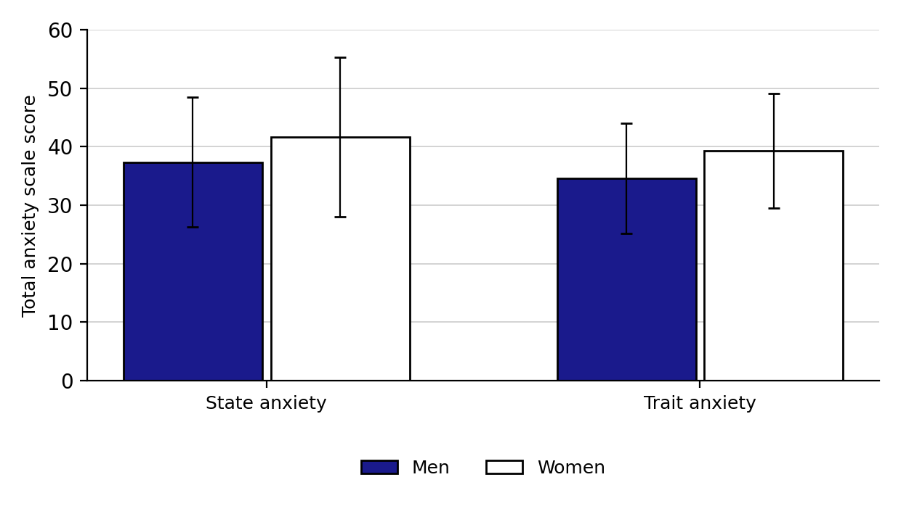
Figure 4.1. Mean values (M) and standard deviations (SD) for State and Trait Anxiety of Men and Women in the Police.
NOTE: The same procedure is followed for the diagrams or images of the Master’s Thesis. Also, the information (data) contained in the tables or figures should be described briefly in the text, with a reference to the corresponding Table or Figure (e.g. see Table 4.1).
CHAPTER V
DISCUSSION
- The chapter always begins with the purpose of the paper and a concise reference to the results.
- An attempt is made to justify the findings in accordance with the research hypotheses of the study and to compare the findings with studies that agree with them and with studies that present conflicting results. Non-significant statistical findings are not discussed, unless they are part of the research hypotheses.
- The argumentation used aims to demonstrate the difference and the superiority of the study conducted, taking into account all its limitations and weaknesses.
- The statistical findings of the study are justified (without presenting statistical indices) in accordance with existing research and theories.
- Finally, research questions that have not been answered and that could form the basis for future research are proposed, and the practical value and application of the results are also discussed.

A.9 Bibliography
The bibliography is an integral part of the MT. It usually contains, in a single list, all the references that the author-researcher has consulted and used. The references in the text and the recording of the bibliography follow the rules of APA 6th Edition (American Psychological Association).
Notes
- Each reference is fully justified.
- References are placed in alphabetical order according to the surname of the first author.
- Greek and foreign bibliographic references must be listed together in alphabetical order, without being separated.
- The bibliography must be written with 1.5 line spacing. The first line of each reference must be aligned with the left margin, while the following lines must be indented by 1 centimetre to the right (the indent is created with the tab key setting). See the sample.
Sample of writing the bibliography
Travlos, A. K. (1998). Psychomotor development of children aged 2-7 years. Athens, Attica: Savvalas. (in Greek)
Violanti, J. M., & Aron, F. (1994). Ranking police stressors. Psychological reports, 75(2), 824-826.

A.10 Appendices
- In the center of the page the word APPENDIX or APPENDICES is written in capital letters, 14 pt.
- In the center of the next page, APPENDIX I is written and below it the title of the appendix.
- On the following page the Appendix is attached (the same procedure is followed for all Appendices).

A.11 Binding of Master’s Theses
The binding of the 2 copies is carried out under the responsibility and at the expense of the authors and must meet the following specifications:
- All copies are leather-bound (with natural leather or imitation leather).
- The colour of the leather is burgundy for Master’s Theses.
- The lettering is gold and is written only on the spine.
- Only the following are written on the spine, from bottom to top: (1) at the bottom, vertically with respect to the length of the spine of the thesis, the Department is written, e.g. T.O.D.A., (2) 6 centimetres higher, vertically with respect to the length of the spine of the thesis, the student registration number is written (the last 7 digits, e.g. 1703001), (3) 10 centimetres higher, horizontally with respect to the length of the spine of the MT, the phrase “MASTER’S THESIS” is written.
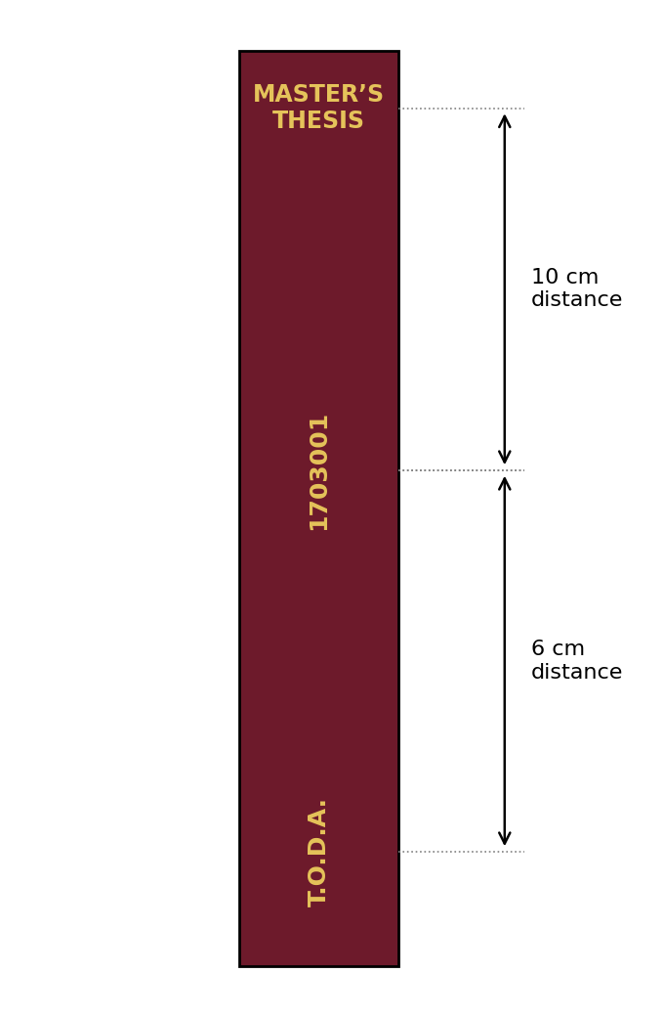
Layout of the lettering on the spine

Part B: Notes on the bibliography
This guide provides instructions for writing bibliographic citations in the text and in the bibliography according to the style recommended by the American Psychological Association (APA 6th Ed.).

B.1 Examples of bibliographic citations in the text
In the introduction and in the literature review, but also wherever else is needed in the text, we refer to other research studies by giving the name of the researcher(s) and the year in which the study was published. With this information, the reader can go back to the list of bibliographic references and find where the work was published. There are two standardized forms for referring to a published work, as shown in the following examples:
- In previous research, most people found the situation realistic (Johnson & Hall, 1999). The symbol & is used inside the parentheses.
- The researchers Johnson and Hall (1999) found that most people found the procedure realistic. The word “and” is used normally outside the parentheses.
- For 3, 4 and 5 authors: Cogdill, Fanderclai, Kilborn, and Williams (2001) but (Cogdill, Fanderclai, Kilborn, & Williams, 2001), and in all subsequent references to the same study Cogdill et al. (2001) or (Cogdill et al., 2001).
- For 7 or more authors, we cite the name of the first author and et al. followed by the year of publication: Adkins et al. (2001) … or (Adkins et al., 2001).
- For authors with the same surname, we put the initials of their first names in front, e.g. R. P. Allen (1994) and D. N. Allen (1998).
- To refer to several studies, we can use the following pattern: Various researchers agree that this situation is realistic for their subjects (Johnson & Hall, 1997, 1999a, 1999b; Kelley, 1986; Michaels, Johnson, & Smith, 1996; Smith & Rodick, 1994). The studies are placed in alphabetical order inside the parentheses and not in chronological order. Also, studies by the same author are separated by a comma without repeating the name, only the year of publication.
- Every time an excerpt of original text is quoted, we must not forget the author of that text (usually placed at the beginning) as well as the page or pages of the original text in parentheses after the closing quotation marks. For example: As Eysenck (1996) argued, “…the main reasons that lead an individual to develop neurotic traits are the environment and heredity” (p. 156).

B.2 Using the appropriate tenses
A scientific paper is a report of something that has happened. The appropriate tense is therefore the past. However, there are some exceptions to this:
- Verbatim reports of a speech (e.g. at a conference) use the tense in which they occurred.
- Instructions for use also use the tense in which they occurred.
- Research hypotheses will include the future tense, since they refer to matters covered by the specific study. The (grammatical) tenses may change significantly within a text, e.g. “Pupils who attend day public schools, and who arrived as immigrants in the last two years, will be less ‘integrated’ into the Greek school reality than those who have been in Greece for more than two years”.
- Observations about contemporary situations will be in the present tense (e.g. “Compulsory education in Greece ends at the age of 15” / “no test exists today that manages to cover all dimensions of personality”).
- Predictions and/or hypotheses about the future will be written in the future tense (e.g. “if the trend of low birth rates continues, Greece will become a country of elderly people”).

B.3 Avoiding the first person
The use of personal pronouns such as ‘I’ or ‘we’ is best avoided. For example, instead of saying “I wanted to examine…”, we can say “it was examined…”, or use another impersonal style of reporting.

B.4 Useful sites
- https://owl.english.purdue.edu/owl/resource/560/01/ – Read the instructions and the examples given in the Purdue OWL guide for in-text citations and the reference list, or consult APA 6th edition, http://www.apastyle.org/
- https://ilrb.cf.ac.uk/citingreferences/apatutorial/index.html – Includes instructions and examples for citations and the reference list.
- http://library.ucol.ac.nz/~upload/LibraryDocuments/APAguiderewriteMay2012plusstatecodes.pdf – Follow the instructions prepared by the Library of the Universal College of Learning (UCOL).
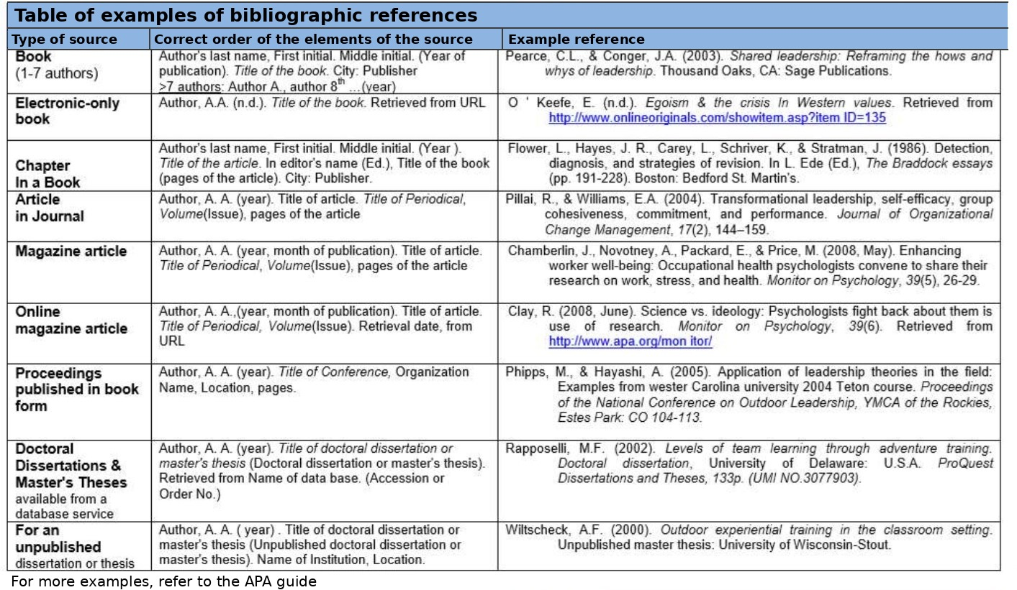
Table of examples of bibliographic references (for further examples see the APA guide).

Part C: Academic ethics and research integrity issues
The purpose of this section of the guide is to raise awareness of, and to highlight, the importance of academic ethics when writing scientific papers, and to provide students with appropriate practical compliance guidelines and examples to avoid. The ultimate goal is to prevent plagiarism, which concerns the individual responsibility of the student to follow the rules of academic ethics and research integrity and to know the penalties, which can even lead to removal from the PSP.

C.1 What is plagiarism – definition
- Any reference, voluntary or involuntary, to the work, words or original ideas of another without a clear citation of the source.
- The use or close paraphrase of the language and ideas of other authors and their presentation as original work.
- Not using quotation marks (“…”) for phrases or paragraphs written by others.
- The use of citations that are not valid.
- Citing the sources only in the bibliography and avoiding their use in the text.
- The word-for-word translation of foreign-language texts – paragraphs – sentences into Greek.
- The “cut and paste” procedure, even with the use of citations.
- Extensive reference to a single source without any differentiation.
- The falsification or fabrication of information or data.
- The use of tables, graphs, questionnaires and other forms without citing their source.
- Self-plagiarism, i.e. the recycling and recombination of old works of the author and their presentation as a new, independent paper.
Also, certain actions, such as buying, stealing or borrowing a ready-made paper, copying an entire paper or an article from the internet, or paying a third person to write a paper, are likewise plagiarism.
Finally, the use of a single paper in two or more courses violates the codes of academic integrity.

C.2 Some examples of what may be characterized as plagiarism
Source: www.psychology.uoc.gr/files/items/6/682/logoklopi
Below is a paragraph from the original article by Mayer, Caruso, and Salovey (2000) entitled “Emotional Intelligence Meets Traditional Standards for an Intelligence”:
Original paragraph (translated into English from the Greek text of the guide):
Emotions are internal processes that coordinate many psychological subsystems, such as psychological reactions, cognitive functions and conscious feelings. Emotions are usually created in response to changes in a person’s relationship with his or her environment. When a person’s relationship with a memory, with his or her family, or with humanity as a whole changes, that person’s emotions will change in turn. For example, a person who recalls a pleasant childhood memory may perceive the world as brighter and happier.
Let us look at an UNACCEPTABLE paraphrase of the above paragraph, which constitutes plagiarism:
Unacceptable paraphrase:
Emotions are internal processes that affect many functions of the person, such as cognitive functions, conscious feelings, and psychological reactions. Emotions are usually caused in response to changes in the person’s relationships with his or her environment. When a person’s relationship with a memory or an experience changes, that person’s emotions will change too. For example, a person who recalls a pleasant childhood memory will perceive the world as happier and brighter.
Why is this plagiarism?
The way this paragraph was worded constitutes plagiarism for two reasons:
- The author simply changed only a few words or phrases, or changed the order in which the sentences of the original text are presented.
- The author did not state where he/she took the specific information mentioned in the paragraph.
Let us now look at an ACCEPTABLE paraphrase of the original paragraph, which does not constitute plagiarism:
Acceptable paraphrase:
According to Mayer, Caruso, and Salovey (2000), emotions are internal processes that coordinate different aspects of human behavior and that are created in response to changes occurring in the person’s environment. Thus, when a person recalls a pleasant event from his or her childhood, his or her mood changes and he or she approaches situations with a positive and optimistic outlook.
Why is this rendering acceptable?
The way this paragraph was worded does not constitute plagiarism for two reasons:
- The author renders the meaning of the original paragraph in his/her own words.
- The author gives the reader the source from which the information presented comes.
Let us now look at another wording of the original paragraph, which is also acceptable and does not constitute plagiarism:
Acceptable wording with a direct quotation:
According to Mayer, Caruso, and Salovey (2000), “Emotions are internal processes that coordinate many psychological subsystems, such as psychological reactions, cognitive functions and conscious feelings” (p. 267). Emotions affect the person’s behavior and are triggered every time something changes in the person’s interaction with his or her environment. Thus, when a person recalls a pleasant event, his or her mood changes and he or she approaches situations with a positive and optimistic outlook.
Why is this rendering acceptable?
The way this paragraph was worded does not constitute plagiarism for three reasons:
- The author presents the information contained in the original text accurately.
- The author gives the reader the source from which the information presented comes.
- The author states precisely which part of the original text is borrowed by putting it in quotation marks, and also states the page on which that part is found.
Note: If the author had not used quotation marks in that particular sentence, there would be an issue of plagiarism, even though the source of that sentence is presented.

Corresponding examples for work prepared in English
Source: http://ori.hhs.gov/sites/default/files/plagiarism.pdf
ORIGINAL PARAGRAPH
“This study examines whether workers of S. invicta are able to assist their mothers in colony usurpations. First we tested whether [queens] of S. invicta are better able to usurp colonies to which their daughters have moved. Second, we tested whether the effect of daughters on usurpation success is due to familiarity with the queen or to genetic relatedness. Aggressive behavior during these usurpation attempts was observed to determine if the presence of familiar or related workers influenced the aggressive response toward either the resident queen or the queen attempting usurpation.”
REWRITTEN VERSION 1:
A study was conducted to examine whether workers of S. invicta can assist their mothers in colony usurpations. The first hypothesis tested was whether queens of S. invicta are better able to usurp colonies to which their daughters have moved. For the second hypothesis, the researchers tested whether the effect of daughters on usurpation success is due to familiarity with the queen or to genetic relatedness. The researchers observed aggressive behavior during these usurpation attempts to determine if the presence of familiar or related workers influenced the aggressive response toward either the resident queen or the queen attempting usurpation.
In this case of text paraphrase (REWRITTEN VERSION 1) there is plagiarism, since the author merely added or replaced a few words at the beginning of each sentence and copied the rest of the content of the sentences verbatim. We observe that although no sentence is identical to that of the source, the author nevertheless appropriated a large part of the original text. The red colour shows the total extent of verbatim use of text from the original.
REWRITTEN VERSION 2:
An investigation was carried out to determine whether S. invicta mothers are helped by their worker offspring during colony usurpations. The study’s focus of investigation was the question of whether colony take-over by S. invicta queens is more effective when their daughters first invade the colonies. One hypothesis concerned the extent to which daughters’ familiarity with the queen, or their genetic similarity to her, affects successful colony take-over. During attempts at taking over another colony, behavioral observations were made of usurping workers that were either familiar or genetically related to the queens to see if these variables were related to aggressive behavior toward the resident or the invading queen
In this case of text paraphrase (REWRITTEN VERSION 2) there is no plagiarism, since a structured paraphrase and rendering of the original text has been achieved, with very few words used verbatim (as shown in red).

C.3 Why awareness and prevention of plagiarism are important
Very often there is no deliberate intention to deceive, and the violation is the result of carelessness or ignorance. To avoid the accusation of plagiarism, it is necessary to pay particular attention to observing some basic rules when using data, ideas, excerpts or texts from articles, books, other papers or online sources. Compliance with academic ethics when writing papers has the following positive effects:
- It shows a high level of careful work, which is one of the general criteria for evaluating any paper.
- It helps the evaluators of the paper to understand better its impact/contribution and its limitations. Ambiguities regarding the above create questions and comments. Clarity regarding the above shows awareness of the limits reached by the paper on the part of the student him/herself – also an important general evaluation criterion.
- Since references are made to recent and important work and papers, the credibility of the paper is strengthened and a high level of knowledge of the field to which the paper belongs is revealed – and this is an important general evaluation criterion of every thesis.
- It is a means of cultivating a critical approach to research and study. (Source: http://www.syros.aegean.gr/users/kgp/plagiarism.html#W3)

C.4 Some useful guidelines for avoiding plagiarism
- When material from an information source is used, an in-text citation is made and the full details of that source are given in the bibliography at the end of the paper.
- It is useful to check the references in the text several times against the bibliography at the end of the paper, so that no source that has been used is omitted.
- The bibliographic citation must allow the reader to go directly to the text from which the information was taken, and indeed to the same edition of the book or article that was used.
- Also, when the student summarizes the words of one or more authors while writing a paper, he/she should, on the one hand, not stitch together the words of others but use his/her own words and, on the other hand, make sufficiently clear where the presentation of the authors’ views or statements ends and where his/her own evaluation or interpretation continues.
There are many established bibliographic styles, e.g. APA, MLA, Harvard and others. This PSP uses the APA bibliographic style in all papers submitted in the context of the courses, as well as in the preparation of the Master’s Thesis.
There are bibliography management programs, such as Mendeley and RefWorks, which offer the possibility of creating and managing a bibliography through a personal account, but which are paid. Correspondingly, there are also several free and quite informative websites on the proper use of in-text citations and of the full bibliography at the end of the paper according to APA and other bibliographic systems. These are the following:
- http://www.worldcat.org/
- http://www.citefast.com/
- http://www.workscited4u.com/
- https://www.citethisforme.com/
- http://endnote.com/
- http://www.citationmachine.net/apa/cite-a-book
- http://www.easybib.com/
There is a plethora of plagiarism detection programs on the internet, as well as useful paraphrasing websites, which are offered to the student as useful tools for preventing plagiarism. The University of the Peloponnese has one of the most widely used software packages for plagiarism checking (TurnItIn), which students can use after contacting the supervisor of the Master’s Thesis.
However, there are also other software packages that are offered free of charge on the internet. Some of these are the following:
- DupliChecker does not require installation; runs directly in a web-page environment http://www.duplichecker.com/
- PaperRater a very good tool that performs a grammar check and a plagiarism check at the same time, and suggests changes to the way of academic writing (e.g. it counts the words used in a sentence) http://www.paperrater.com/
- Plagiarisma.net does not require installation; runs directly in a web-page environment; also offered for the Greek language http://plagiarisma.net/
- Plagiarism Software does not require installation; runs directly in a web-page environment http://www.plagiarismsoftware.net/
- Plagium does not require installation; runs directly in a web-page environment http://www.plagium.com/
- PlagTracker does not require installation; runs directly in a web-page environment http://www.plagtracker.com/
- Viper the installation instructions of the software are found on the following site http://www.scanmyessay.com/
- SeeSources does not require installation; runs directly in a web-page environment http://www.plagscan.com/seesources/analyse.php
- Plagiarism Detector does not require installation; runs directly in a web-page environment http://plagiarismdetector.net/
- Plagiarism Checker does not require installation; runs directly in a web-page environment. The same site also offers useful tools such as a text rewriter (article rewriter) http://smallseotools.com/plagiarism-checker/ and http://smallseotools.com/article-rewriter/
- DOC Cop can check text of up to 180,000 words https://www.doccop.com/index.html?nc=0.18362667
- Reprint Writers does not require installation; runs directly in a web-page environment http://www.reprintwriters.com/copyrightchecker/check.php

For aesthetic reasons in this MT writing guide, either the masculine or the feminine gender will be used. In no case should the reader assume that the use of one gender is made for sexist reasons.

